Introductions:

Purpose of the Boosters:
- We are here to support the North Allegheny Boys Soccer program, athletes & coaches
- We are not involved with coaching or rostering decisions
- We are a non-profit organization run by parent volunteers
- All Booster information can be found at https://www.natigersoccer.com/

2025 Booster Board Members:
- President: Brian Sullenger (Contact info: 412-680-9768 or bmsullenger@gmail.com)
- Treasurers: Anne Stalter & Mike Herzog
- Special Events Coordinators: Claudine Martin & Maura Paczan
- Concession Stand Coordinator: Joe Vojtas & Jeff Vaders
- Information Technology: TBD

Coaches:

Manuel Montero (Varsity) | John Kowalski (Asst Varsity) | Lenny Muckle (JV)
Alessandro Moreira (Black Team) | Joey Saez (Gold Team) | Javin Melvin (White Team)

In Season Communication:

The majority of communication during the season will come through SportsYou. The Booster Board and Team Parents will be setting up the teams shortly. You will receive an invitation via email to join the SportsYou group for the team your son is rostered on. Both rostered players and parents must register to ensure important information is received regarding schedule updates and other team related content.

Season Overview 2025:

All game schedules are available on the North Allegheny website:

Varsity and JV http://athletics.northallegheny.org/boys-soccer/schedule-results/

Black Team (9th Grade) http://athletics.northallegheny.org/boys-soccer/freshman-schedule/

Gold (8th) & White (7th) Teams http://athletics.northallegheny.org/boys-soccer/junior-high-schedules/

Booster Events 2025:

Event | Date | Details
Fall Parent Meeting | 8/13/25
Uniform Distribution | JV & Varsity – 8/14/25 | Black, Gold & White Teams during week of 8/18/25
Spirit Wear Orders | Open thru 8/31/25 | Visit www.natigersoccer.com for the link
Team Photos | JV & Varsity – 8/15/25 | Black, Gold & White Teams during practice on 8/22/2025
Black, Gold & White Team Recognition and Pack the Pitch | 9/20/25
Senior Recognition | 9/25/25
Soccer Banquet | 11/18/25 | Open to Varsity, JV and Black teams; Gold and White teams will have individual team celebrations

Responsibilities:

- Booster Dues (All Teams)
  - BOOSTER DUES MUST BE PAID BEFORE A PLAYER WILL BE ISSUED A UNIFORM
  - JV & Varsity Booster Dues for 2025 are $250/player
  - Black, Gold & White Team Booster Dues for 2024 are $125/player
  - Booster dues may be remitted in one of two ways:
- Using PayPal (PREFERRED)
- Use this Link: https://paypal.me/NABSboosters?country.x=US&locale.x=en_US
- Send money to our PayPal ID: @NABSboosters
- Scan the QR codes provided at the end of this document with your phone’s camera
- By personal check payable to NABS Boosters
  - If paying by check, you must provide separate checks for the Booster Dues and Uniform Deposit as the uniform deposit check will only be cashed if the players full uniform kit is not returned at the end of the season, please note “dues” in memo

- Uniform Deposit (All Teams)
    - UNIFORM DEPOSIT MUST BE RECEIVED BEFORE A PLAYER WILL BE ISSUED A UNIFORM
- JV & Varsity
  - Submit a uniform kit deposit of $250 via check made payable to NABS Boosters (Will not be cashed unless full uniform kit is not returned).
  - Please do not remit this deposit using PayPal.
- Black, Gold & White Teams
  - Submit a uniform kit deposit of $150 via check made payable to NABS Boosters (Will not be cashed unless full uniform kit is not returned).
  - Please do not remit this deposit using PayPal.

- Practice Uniforms
  - All players are required to have both black and gray training kits. Practice jerseys are $30 each and practice shorts are $25 each.
  - If you have training kits from last year, you do not need to purchase new ones.
  - Varsity and JV players are required to also have a pullover hoodie ($50) and an NA soccer bag ($45).
  - Practice kits will be available for purchase at practice.
- Concession Stand (All Teams)
    - Each family must cover at least 2 concession shifts per child in the NABS program (i.e. 1 player = 2 shifts and 2 players = 4 shifts)
    - Have added a Pretzel Factory pickup role for each home game that counts toward 1 of your concession stand shifts (Pretzels need to be delivered 30 minutes prior to the start of the JV match)
    - Additional games will be added for soccer playoffs, football playoffs, and neutral site games hosted at North Allegheny
    - Sign-up link can be found on NABS website: www.natigersoccer.com

- Ball Boy Duties (Black, Gold & White Teams)
    - Each player on the Black, Gold & White Teams is expected to cover two ball-boy shifts during home JV or Varsity soccer matches
    - Sign-up link can be found on NABS website: www.natigersoccer.com

- Fundraising (All Teams)
    - Each player will need to provide 20 email addresses and 20 phone numbers for our fundraising opportunity
    - We are using an online fundraising program through Snap Mobile
    - Anyone who donates will receive a virtual gift card that can be used at local and national businesses

Schedules:

- Black, Gold & White Teams: Practices and other team events will be communicated thru SportsYou and this information will be forthcoming soon.

- JV & Varsity Teams:

  - Thursday, August 14th
    - Camp Guyasuta Team Outing (arrive at Blueberry Park by 8am) 9am – 1pm
    - Team Bonding and Picnic from 2 – 5pm (Blueberry Hill Park)
      - Includes Fundraising Initiation
      - Uniform Distribution immediately following picnic
    - Note – NABS Boosters will provide food and drinks for the picnic

  - Friday, August 15th
    - Practice from 10:15am – 12:15pm (NAI Turf)
    - Team Photos at 4 – 5:30pm (NASH Campus) [Players must bring black soccer socks]
    - Team Meetings/Bonding Activities at 5:30 – 7pm (NASH Campus)
    - Note – NABS Boosters will provide food and drinks for players after pictures.

  - Saturday, August 16th
    - Varsity Scrimmage @ Peters Township at 10am
    - JV Scrimmage @ Peters Township at 11:30am

Volunteer Opportunities:

The current NABS Booster leadership group volunteered at the end of the previous season, and this small group of officers has been working hard all summer long to prepare for the upcoming season.

As rosters are finalized, it is critical that additional volunteers are confirmed to assist with the various duties required of the Soccer Boosters. If you are interested or willing to volunteer, please contact Brian Sullenger at 412-680-9768 or bmsullenger@gmail.com

Specific Volunteer Needs Include:
- Team Parents
- Team Photographers
- Special Events Committee Members
- Concession Stand Committee Members

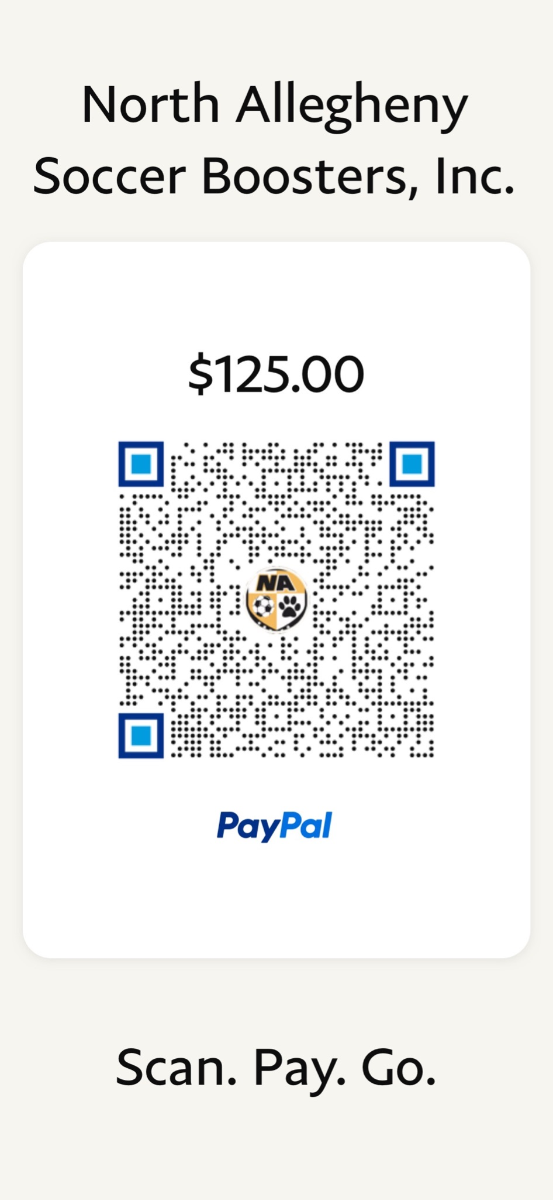
JV/Varsity Booster Dues Black, Gold & White Team Booster Dues
