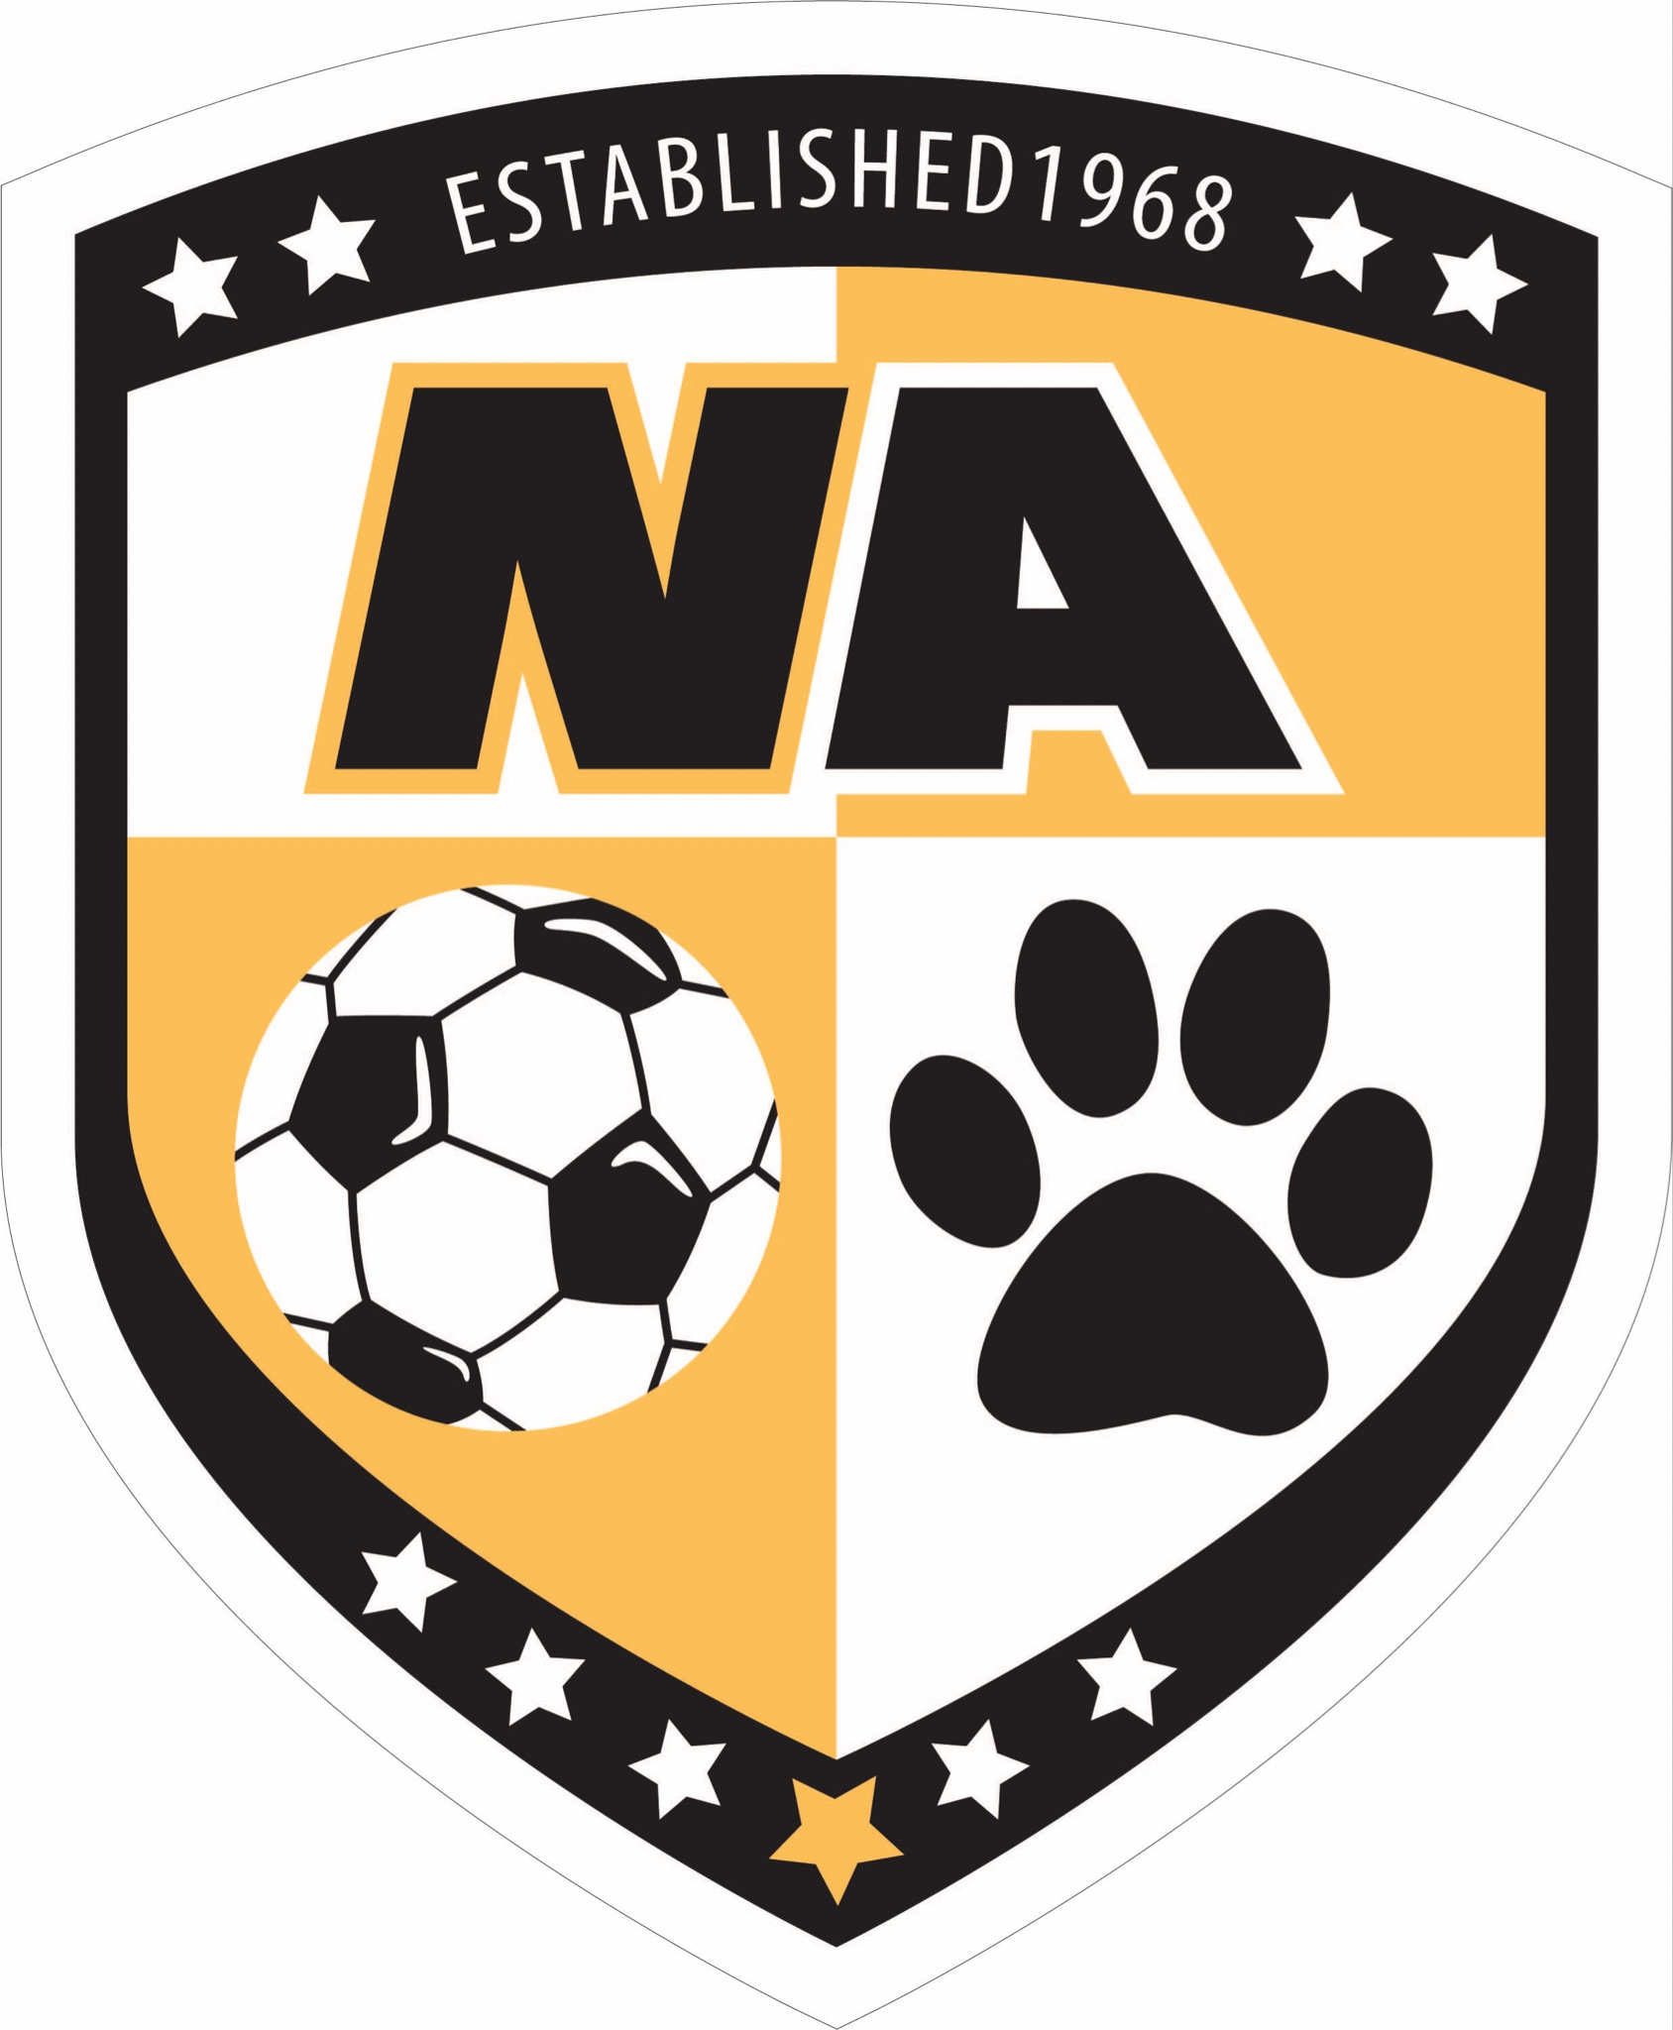

**NORTH ALLEGHENY BOYS SOCCER**

**2025-2026 HANDBOOK**

1. **INTRODUCTION**

As we approach the start of the 2025-26 North Allegheny Boys Soccer (NABS) season, the 57th year of this storied program, we wanted to pass along some important information to all parents of NABS prospects. Please read this information entirely before asking any questions.

Coach Manuel Montero enters his fourth season as Head Coach of NABS, following coaches Bruno Schwarz (‘68-’04) and Bobby Vosmaer (‘05-’21). With his extensive experience coaching soccer at the club, high school, and collegiate level, Coach Montero is focused first and foremost on the development of his players as athletes, competitors, and outstanding young men. As a U.S. Army veteran, Coach Montero’s coaching style emphasizes the virtues of discipline, respect, and courage.

It is easy to see Coach Montero’s vision for the future of the NABS program take shape. In only his second season as Head Coach, Coach Montero realized one of the best regular season records in program history with 14W, 1L, and 3T. In the post-season, Coach Montero took NABS to its first WPIAL AAAA Championship match since winning back-to-back WPIAL titles in 2016-17 and 2017-18, where NABS was edged out 2-1 by Norwin in the PK shootout that followed a 2OT stalemate. Despite the narrow defeat, the second-place WPIAL finish qualified NABS for the PIAA state tournament - its first appearance since 2017. Our state title run was ended in the PIAA quarterfinal match by Central Bucks South, a team that ultimately went on to play in a tightly contested PIAA Championship match against perennial PIAA state title contender Conestoga HS.

The NABS Boosters organization has played a central role in the operations of NABS for decades and has been a key partner in the program’s success. The NABS Boosters is committed to help Coach Montero continue to build his vision for the future of the NABS program, and there are many opportunities for all to become involved in something that is sure to be one of your son’s fondest memories of their time as a North Allegheny student-athlete.

We realize that the parents of NABS prospects especially those new to the program, are likely to have many questions. This document is intended to provide some general information regarding the upcoming season and the expectations of program participants. We hope that this document will answer many of the questions you may have.

**2. COMMUNICATIONS PLATFORM**

North Allegheny Athletics requires the use of the SportsYou app for all team communications and scheduling. Details on using the SportsYou app will be circulated upon roster acceptance.

**3. LEADERSHIP CAMP AND TEAM PICNIC**

**Note: These events are limited to JUNIOR VARSITY and VARSITY rostered athletes only.**

All players accepting JV and Varsity roster spots will be expected to attend the NABS Leadership Camp held at [Camp Guyasuta](https://campguyasuta.org/) on Thursday, August 14 from 9:00am – 1:00pm. The camp is an opportunity for players to get to know their teammates and coaches better and also begin to form the bonds that are crucial to success on the field. That afternoon, NABS Boosters will be sponsoring a team picnic at Blueberry Hill Park, Franklin Park Township, from 2:00 - 5:00pm for all JV and Varsity rostered players. Uniforms will be handed out following the picnic.

Transportation will be provided from Blueberry Hill Park to Camp Guyasuta. Athletes are expected to **arrive at Blueberry Hill Park by 7:45am (by Pickleball courts) for a team meeting** and team bonding activities. The bus for Camp Guyasuta will leave from Blueberry Hill Park at 8:15am, and will return to Blueberry Hill Park in time for the picnic. Athletes leaving their cars for Camp Guyasuta can park next to the pickleball courts.

In addition to the Team Bonding event, all JV/Varsity rostered players are expected to attend the following activities **(All Activities at NASH unless otherwise noted):**

**Friday, August 15**

* JV/Varsity Practice from 10:15am – 12:15pm (NAI)
* JV/Varsity Photos from 4 – 5:30 PM (Baierl Center)
* Team Meetings/Bonding Activities from 5:30 – 7pm
* Note – NABS Boosters will provide subs, drinks and desserts for players after pictures.

**4. NABS BOOSTERS ORGANIZATION**

**4.1 Boosters Activities and Benefits**

If your son has participated in the NABS program in previous seasons, you are already acquainted with the NABS Boosters organization and understand how much it does to support the NABS program both operationally and financially. For those new to the program, NABS Boosters organizes and/or subsidizes events throughout the season that includes: the Pre-Season Picnic, Senior Night, Pack the Pitch/SoccerFest, team dinners, middle school pizza parties, team photos, Middle School Recognition Night, and the NABS Banquet at the end of the season. The NABS boosters also subsidizes the costs of some field/training equipment, match video recordings, uniform articles, and an additional coaching stipend. The NABS Boosters is responsible for organizing fundraising activities that augment Booster dues, such as manning the concession stand for NA athletic events.

NABS Boosters is a tax-exempt 501c(3) registered entity.

**4.2 Booster Dues**

The NABS Booster dues schedule for the 2025-26 season is as follows:

**Junior Varsity/Varsity Team:**  **$250/season**

**Black, Gold & White Teams:**  **$125/season**

The Booster dues schedule corresponds to the team your child is rostered on. Instances where a 9th grader is rostered on Junior Varsity or Varsity teams, the JV/Varsity dues apply.

**Booster dues are a participation requirement and must be paid in full upon roster acceptance and prior to uniform distribution (see below).** The NABS Booster dues schedule is comparable to other NA team sports and is intended to place less emphasis on fundraising initiatives that depend largely on the participation and the finances of the parents of NABS athletes. **Your child will not be issued a uniform until dues and a uniform deposit have been collected.**

In the event that extreme financial hardship or extenuating family circumstances would prevent an athlete’s participation in NABS, a parent or guardian of the athlete is encouraged to contact NABS boosters President Brian Sullenger at 412-680-9768 or [bmsullenger@gmail.com](mailto:bmsullenger@gmail.com) to discuss potentially reducing or waiving booster dues. This discussion will be kept in complete confidence.

**Booster dues** may be remitted in one of two ways:

1.) Using Paypal (PREFERRED)

* Use this Link: <https://paypal.me/NABSboosters?country.x=US&locale.x=en_US>
* Send money to our PayPal ID: @NABSboosters
* Scan the QR codes provided at the end of this document with your phone’s camera

2.) By personal check payable to NABS Boosters.

If paying by check, please be prepared on Aug. 14th with **separate checks** for the required Booster dues and uniform deposit for the team your son is rostered on. We do not cash the uniform deposit check upon receipt.

Payments must be received **before uniforms are distributed.** For JV and Varsity athletes, that will be **after the team picnic on Thursday, August 14th.** Athletes will need them for team photos taken on Fridayand also our first pre-season match on Saturday Aug. 16th.White, Gold, and Black team uniforms will be distributed during the week of Aug. 18th. See section 6.5 below for more details.

**4.3 Booster Organization Obligations**

Every family of a rostered NABS athlete belongs to and is a beneficiary of the NABS Boosters Association. NABS could not function without the operational and financial support of the Boosters, and the NABS Boosters could not function without the volunteer efforts of NABS families. We hope that all will recognize the importance of the NABS Boosters and the support they provide to the athletes, coaches, and the NABS program as a whole. We also hope that this will encourage all families to volunteer a little of their time to help with the many NABS Booster functions. Volunteering to assist the Boosters is a great way to get to know other NABS parents, many of whom will become more familiar and friendly as your child progresses through the program. Being active in the NABS Boosters ensures that parents have an opportunity for some funalong with their sons! Volunteering in any capacity is greatly appreciated and strongly encouraged.

In addition to many optional NABS Boosters volunteer roles, e**ach family will maintain two mandatory obligations to the NABS Boosters: (1) remitting NABS Booster dues & uniform deposit, and (2) staffing the concession stand.** Staffing the concession stand at NABS matches and NA football games provides as much financial support for the NABS program as the sum of all Booster dues collected. Together, these two principal income sources support most of the NABS program budget. **Every family of an NABS athlete(s) is required to work at least two concession stand shifts during the season**, regardless of your son’s grade level or the number of children you have in the NABS program. This has long been a program obligation, and it represents a commitment of only a few hours of service to the organization over an entire season. Compliance with this obligation has not required aggressive enforcement, but over the past few seasons it became clear that fewer families were taking this obligation seriously. This has unfairly burdened those willing to volunteer. If NABS Boosters declined to share in concessions operations, we would have to double our program dues or curtail many enriching and fun activities for athletes and their families. Between regular season and post-season soccer and football matches, there are ample opportunities for families to meet their concession stand obligation. It can be fun and is also a great opportunity to get to know others if you are a newcomer!

When an athlete is issued their uniform, a deposit is required to ensure that uniforms are returned in good condition. This deposit also serves as collateral to ensure compliance with the concession stand staffing requirement (see section 5.4 below).

**5. UNIFORMS**

**5.1 Requirements**

Some of the uniform articles are the property of the NA school district and NABS Boosters and are issued to the players for the duration of the season. These are the match kits, warm-up pants, and the waterproof cold-weather parka. These articles are the property of the NA School District (NASD) and must be returned at the end of the season.

Some additional uniform articles are a program requirement. These additional uniform articles (see below) are purchased by the athletes upon roster acceptance and are theirs to keep. These items do not need to be purchased every season. The expectation is that athletes will purchase these articles once and use them until they graduate, are outgrown, lost, or become otherwise unwearable. The exception is those athletes transitioning from MS rosters to JV/Varsity rosters, who will be required to purchase the training hoodie and backpack. Athletes new to the program, which will primarily be rising 7th graders, will need to purchase the complete training kit required for their roster level (either MS or V/JV teams). The uniform requirements differ for middle school and Varsity/JV teams, but the styles are continuous across all five NABS teams. Athletes who need a larger size or to replace a missing item can purchase only the items they need. The NABS Boosters is assisting Coach Montero and NA Athletics with the ordering and distribution of these additional uniform articles, including collecting funds to reimburse the Athletics department for their purchase.

In addition, each player in the NABS program will receive a senior-designed Dri-fit T-shirt sponsored by the NABS Boosters at no cost. This is a NABS tradition, and the senior-designed T-shirt can be worn to school, workouts, out on the town, etc. to promote awareness and excitement for the upcoming season.

**5.2 Junior Varsity and Varsity Uniform Package**

The 2025-26 uniform package for Junior Varsity and Varsity rostered athletes is:

**Basic Uniform Articles:**

Home Match Kit (Black) - Must be returned at end of season

Away Match Kit (White) – Must be returned at end of season

Pre-match jerseys (Yellow) – Must be returned at end of season

Home Socks (Black) - Do not need to be returned

Away Socks (White) – Do not need to be returned

Waterproof Bench Parka – Must be returned at end of season

Warm-up pants – Must be returned at end of season

**Additional JV/V Required Uniform Articles:**

Black Nike Tiempo II Practice jersey: $30

Black Nike Classic II Practice short: $25

Grey Nike Tiempo II Practice jersey: $30

Grey Nike Classic II Practice short: $25

Black Nike Therma pullover hoodie: $50

Grey Nike Academy backpack: $45

Many athletes last season wanted to wear their team-issued parka to non-NABS events, and some expressed interest in purchasing them. To limit wear and loss to the on-loan uniform articles, we ask that athletes reserve their use for NABS events. Several parkas were not returned or returned damaged and had to be re-ordered. This year we will be offering the exact same parka, as well as other options in the NABS Spiritwear shop (see section 7 below). Athletes may decline the team-issued parka and order their own parka to keep and use as they wish.

**5.3 Black, Gold & White Team Uniform Package**

The 2025-26 uniform package for Black, Gold & White rostered athletes is:

**Basic Uniform Articles:**

Home Match Kit (Black) - Must be returned at end of season

Away Match Kit (White) – Must be returned at end of season

Home Socks (Black) - Do not need to be returned

Away Socks (White) – Do not need to be returned

**Additional Middle School Required Uniform Articles:**

Black Nike Tiempo II Practice jersey: $30

Black Nike Classic II Practice short: $25

Grey Nike Tiempo II Practice jersey: $30

Grey Nike Classic II Practice short: $25

The NABS Boosters will have a sufficient stock of these articles to meet the expected roster needs this season. We will distribute them and collect payments at a time TBD. Details will be circulated to athletes after roster acceptance. However, we cannot guarantee that we will have surplus stock in the required size.

**5.4 Uniform Deposit/Collateral**

**In addition to Booster Dues, collateral of $250 for JV/Varsity rostered players and $150 for Black, Gold White rostered players are required to:**

1. Reimburse NASD for any lost or damaged uniform articles. The uniforms are the property of NASD and the NABS Boosters association assumes responsibility for their return to NASD at the end of season.

1. Ensure that all NABS families fulfill their obligation to staff the concession stand.

**The uniform deposit/collateral MUST be furnished when uniforms are distributed with a personal check made out to NABS Boosters with “Uniform Deposit” in the memo line. Uniforms will not be distributed to a player without receipt of the deposit check.** **This check will be held by the NABS Boosters treasurer in a safe location and will be destroyed at the end of season once it is verified that the uniform has been returned in good condition and the family has met its concession stand obligation**. Other uniform articles are the property of the athlete and do not need to be returned at the end of the season.

**5.5 Uniform Distribution Procedure**

JV and Varsity Uniforms will be distributed at **Blueberry on Thursday August 14th at the picnic**.

Black, Gold, and White team uniforms will be distributed the week of August 18th after practice.

**Team uniforms are the property of the NA School District and the NABS Boosters assumes responsibility for issuing and collecting team uniforms at the end of the season. Uniforms will not be distributed to your child until payments have been received. Please see the checklist at the end of this document.**

JV and Varsity players will be able to select from the available jersey numbers in their preferred size based on a prioritization scheme at the discretion of Coach Montero. Black, Gold and White Team uniforms will be distributed to optimize fit across the team. Number selection will be the same as for JV and Varsity, with Cooper test times determining the order in which players select their jersey number. Note that a player’s first choice jersey number may not be available in their ideal size. Practice kits, sweatshirts, and parkas are not numbered as a player’s jersey number may not be the same from season to season.

**6. LOCKER ROOM**

The expansive NABS locker room is an important resource that would be the envy of some collegiate soccer programs! Each JV and Varsity athlete will be assigned a locker with a personalized nameplate that is theirs to use exclusively throughout the season. Athletes should bring a combination lock to secure their belongings. The NABS locker room will also be used for video analysis sessions, pre-match preparation, and most importantly a post-match recovery program that Coach Montero is implementing with the assistance of NA athletic trainers.

**7. NABS SPIRITWEAR SALE**

The NABS Boosters hosts an annual Spiritwear sale. All sales will be transacted at our online NABS Spiritwear Store run through BSN. The website is now live and ready to take orders and will remain open until Sunday, August 31st at midnight. Items will be delivered directly to you via the USPS. A portion of the proceeds benefits NABS Boosters, so you are supporting both your child’s NABS team and the NABS Boosters by shopping our Spiritwear sale.

**8. PARENT MEETING**

**There will be a parent meeting on Wednesday, August 13 at 7:30 PM in the Ponce Room of the Baierl Center. Parents of rostered NABS athletes are strongly encouraged to attend.**

**9. NABS BOOSTERS OFFICERS AND VOLUNTEER POSITIONS**

The NABS Booster board comprises a President, Vice President, Co-Treasurers, Concessions Coordinator, and a Special Events Coordinator(s). The current NABS Booster leadership volunteered at the end of the previous season, and this small group of officers has been working hard all summer long to prepare for the upcoming season.

Once rosters are announced, it is critical that additional volunteers are confirmed to assist with the various duties required of the Soccer Boosters. If you are interested or willing to volunteer, please contact Brian Sullenger at 412-680-9768 or bmsullenger@gmail.com

**10. TEAM PHOTOS**

Individual and team photos are **tentatively** scheduled as follows:

Junior Varsity/Varsity teams: Friday, August 15th from 4:00 – 5:30pm at NASH stadium.

Black, Gold & White teams: Friday August 22nd during practice

All athletes should be dressed in **their black match kits**, **including socks**. There may be additional requirements for seniors - these will be communicated directly to them.

**11. WEBSITE AND SOCIAL MEDIA**

Information about the NABS program including schedules, rosters, news stories, and photos can be found in one of two places:

North Allegheny Sports Network, [The NA Athletics Department Website](https://athletics.northallegheny.org/boys-soccer/)

The NABS Booster-maintained website, [www.natigersoccer.com](http://www.natigersoccer.com)

NABS also sponsors several social media accounts:

NABS Alumni Facebook Group:

<https://www.facebook.com/groups/nabsalumni>

NABS:Facebook Page: <https://www.facebook.com/North-Allegheny-Boys-Soccer-100272162794809>

Twitter:

@NASoccer1968

Instagram:

@natigersoccer

MaxPreps, a resource for college athletics recruitment:

<https://www.maxpreps.com/pa/wexford/north-allegheny-tigers/soccer/>

Please help us to promote the NABS program through our social media outlets!

**12. FUNDRAISER**

This year we have teamed with SnapMobile to raise money for the program. We are looking to continue to upgrade our facilities, including locker room upgrades, provide recovery tools and improve the experience for all kids in the program. Each athlete needs to provide 20 e-mail addresses and 20 phone numbers. A representative from Snap Mobile will be onsite at a practice to help the boys get onboarded and start the fundraiser. Anyone who donates to this fundraiser will receive a virtual gift card that can be used at businesses locally and nationally.

**13. IMPORTANT DATES**

**Weds. 8/13:** - Parent meeting, Baierl Center, Ponce Room, NASH, 7:30 PM.

**Thurs. 8/14:** - Camp Guyasuta for JV/V, 9am – 1pm

- JV/V team bonding activities, 2 – 5pm

∙ Will include uniform distribution

**Fri. 8/15:** - JV/V Team Pictures 4 – 5:30pm at NASH

**-** JV/V Team building and meetings 5:30 – 7pm at NASH

**Sat. 8/16:** - Preseason match @ Peters Twp., Varsity at 10am and JV @ 11:30am

**CHECKLIST**

**1. Attend tryouts.** Note that prospects that did not complete NASD pre-participation requirements will not be able to try out. Prospects must attend all three days of tryouts.

**2. Look out for roster announcements**

**Junior Varsity and Varsity Prospects:** Monitor the [NA Athletics website](https://athletics.northallegheny.org/boys-soccer/roster/) on Wednesday, Aug. 13th for roster announcements. The NA Athletics department must certify the eligibility of all rostered athletes before official rosters can be released.

**Black, Gold, and White Team Prospects:** Roster announcements are made on-field following the last day of tryouts. The NA Athletics department must certify the eligibility of all rostered athletes before official rosters can be released.

**3. Accept roster offer**. Acceptance of a roster offer is implicit unless Coach Montero is notified that your child is declining. Please let Coach Montero know ASAP if you are declining.

**4. Pay Booster Dues.** Payment of booster dues is required upon roster acceptance. Dues should be remitted by PayPal (preferred) or alternatively by personal check. Dues are $250 for Junior Varsity and Varsity athletes, and $125 for middle school (White, Black, Gold) rosters.

To pay via PayPal you can:

* Use this Link: <https://paypal.me/NABSboosters?country.x=US&locale.x=en_US>
* Send money to our PayPal ID: @NABSboosters
* Scan the corresponding QR codes (JV/V: $250. MS: $125) below with your phone’s camera

**5. Collect Uniforms!**

**Junior Varsity and Varsity Prospects:** Uniforms will be distributed on Thursday, Aug 14th following the picnic at Blueberry park. Each athlete should be prepared with the following:

* A $250 check payable to NABS Boosters for your annual dues if you did not pay using PayPal
* A $250 check payable to NABS Boosters for the uniform deposit/collateral (will not be cashed). **Please do not remit this deposit using PayPal.**

**Black, Gold & White Prospects:** Uniforms will be distributed prior to the first preseason match for the team your son is rostered on. Communication will be through your team parent.

* A $125 check payable to NABS Boosters for your annual dues if you did not pay using PayPal
* A $150 check payable to NABS Boosters for the uniform deposit/collateral (will not be cashed). **Please do not remit this deposit using PayPal.**

**6. Become a NABS Booster Volunteer - If** you are interested in volunteering, please notify NABS Boosters President Brian Sullenger at 412-680-9768 or [bmsullenger@gmail.com](mailto:bmsullenger@gmail.com) expressing your intentions to volunteer. You do not need to notify Brian of your volunteering for concession stand duties - that is implicit upon roster acceptance.

**7. Attend Parent Meeting** on Weds, August 13 at 7:30 PM in the Ponce Room of the Baierl Center. We will go into more detail regarding the season’s events and recruit volunteers for Boosters functions.

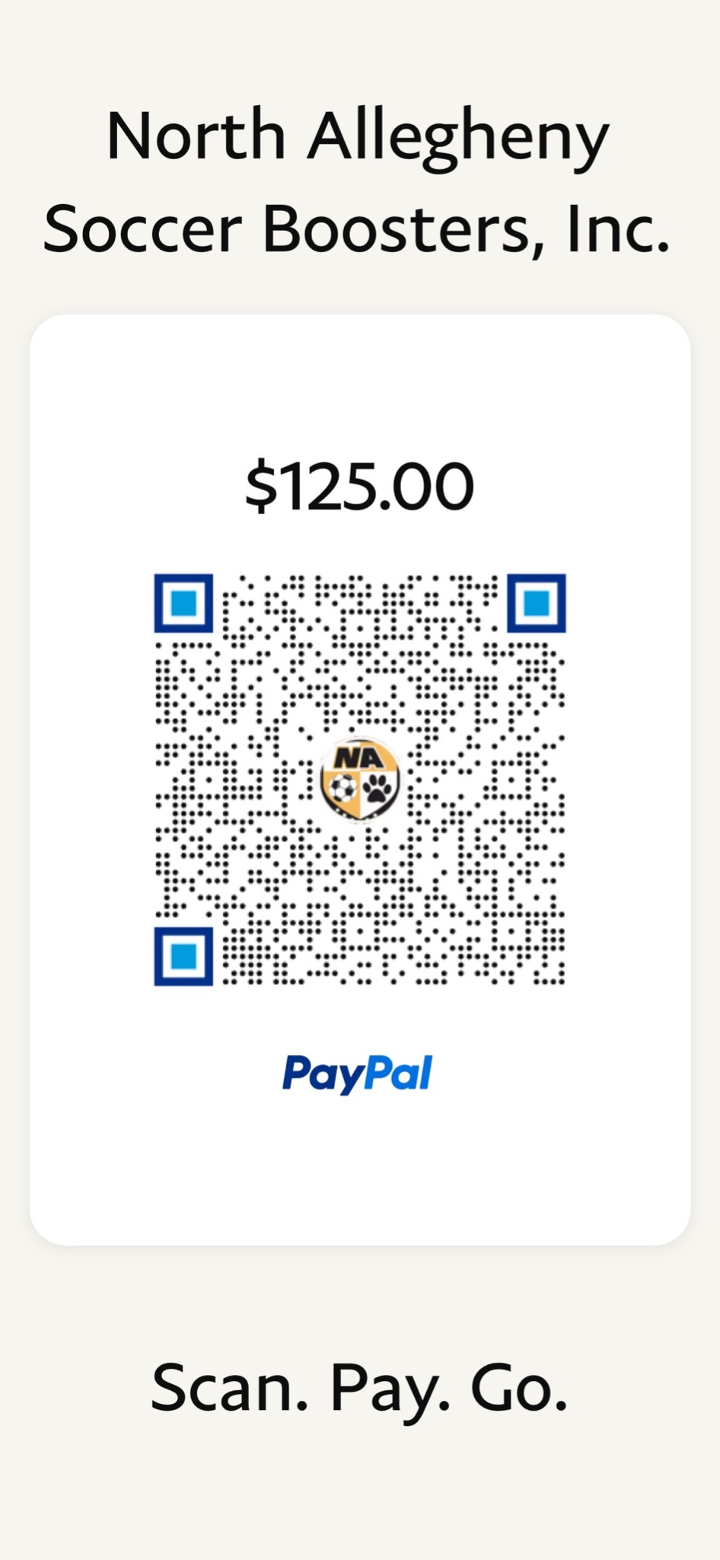**JV/Varsity Booster Dues Black, Gold & White Team Booster Dues**