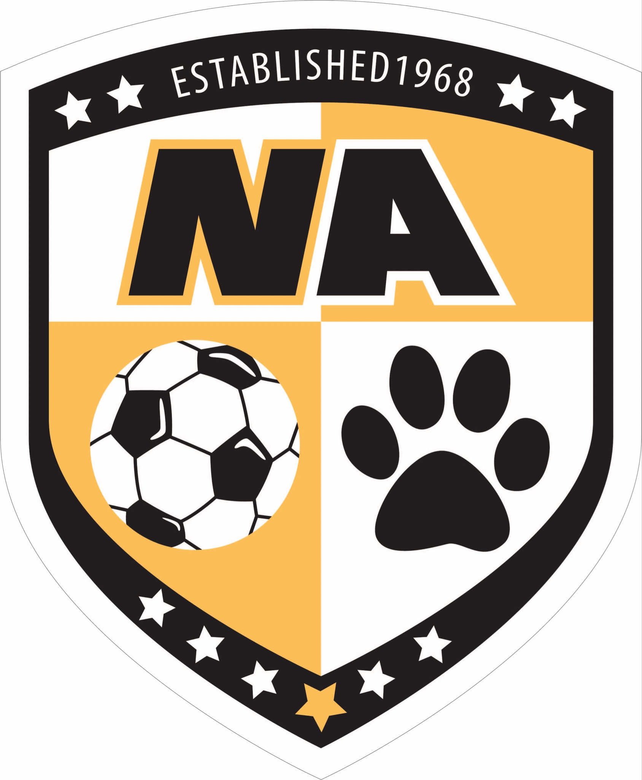

**NORTH ALLEGHENY BOYS SOCCER**

**2025-2026 PRESEASON INFORMATION**

1. **INTRODUCTION**

As we approach tryouts for the 2025-26 North Allegheny Boys Soccer (NABS) season, the 57th year of this storied program, we wanted to pass along some important information regarding tryouts to all parents of NABS prospects. Please read this information entirely before asking any questions.

1. **TRYOUTS**

In order to tryout for the Fall 2025 school season (middle and high school), your son will need to have the following:

* Impact testing (concussion test)
* Physical
  + Needs to be done *after Thursday May 1*, 2025 and before tryouts
  + Needs to be done on your own
* Family ID
  + Filling out basic information for your son
  + [Link](https://athletics.northallegheny.org/news/spring-sports-registration-2/) will be open after June 1st
* Pay Family ID
  + $75 (refundable if your child does not make the team)
  + After June 1st

Again, your son WILL NOT be able to participate in tryouts until those things are taken care of. There are no exceptions.

**2.1 Tryout Location and Schedule**

**Rising 10th, 11th, & 12th graders:**

Tryouts for **JV and Varsity** will be held at North Allegheny Senior High School:

North Allegheny Senior High School (NASH)

10375 Perry Highway

Wexford, PA 15090

August 11, 12, 13

10:15 AM – 12:15 PM

**Rising 9th Graders:**

Tryouts for **rising 9th graders** will be held at North Allegheny Intermediate Turf Field:

North Allegheny Intermediate (NAI)

350 Cumberland Rd

Pittsburgh, PA 15237

August 11, 12, 13

10:30 AM – 12:30 PM

**Note: Only selected 9th graders will be invited to tryout with upperclassmen beginning August 12th. Invites will come directly from NABS coaching staff. Every 9th grader needs to report to 9th grade tryouts on Monday Aug. 11th.**

**Rising 7th and 8th graders:**

Tryouts for **rising 7th and 8th graders** will be held at North Allegheny Intermediate Turf Field:

North Allegheny Intermediate (NAI)

350 Cumberland Rd

Pittsburgh, PA 15237

August 11, 12, 13

12:30 PM – 2:30 PM at NAI Turf

**IMPORTANT:** **All NABS prospects** **must attend** **all three tryout dates**.

Please **plan to arrive at least 20 min** before the start of the scheduled tryout time as Coach Montero will get started promptly and **athletes are expected to warm up on their own**. NABS Booster representatives will help check kids in at tryouts and pass out pinnies.

All NABS prospects must bring the following to each day of tryouts:

- Soccer cleats

- Running shoes

- Shinguards

- Water

- Sunscreen

NABS coaches will be evaluating the technical, tactical, physical, and mental aspects of the game.

**2.2 Tryout Format**

|  |  |  |
| --- | --- | --- |
| **Day 1:** | **Day 2:** | **Day 3:** |
| * Warm-up (on their own prior to start time) * [Cooper test](https://en.wikipedia.org/wiki/Cooper_test) * 40 yd dash * Passing technical * 1v1s * Scrimmage | * Warm-up (on their own prior to start time) * [Beep Test](https://en.wikipedia.org/wiki/Multi-stage_fitness_test) * 30 yd dash * 3v3’s * Scrimmage | * Warm-up (on their own prior to start time) * Passing technical * Positional Play * Scrimmage |

**Note:** The Cooper and Beep tests will begin promptly at the beginning of the JV & Varsity tryout. If a player is late, they will not be able to run it and will not have a data point. The Cooper test will help us determine a prospect’s current fitness level and speed. The Cooper test will determine the order in which kids that make a roster will select their jersey number. The lower their Cooper test time, the higher the pick they will earn.

**3. ROSTERING**

Roster decisions for all NABS teams will be strictly merit based and made with the overarching goal of maximizing player development across the five NABS teams. Your child’s roster placement will give full consideration to their physical, technical, tactical, and mental abilities at the current stage of their development.

**3.1 Rostering Philosophy**

One key change implemented by Coach Montero for NABS is that athletes are not rostered strictly according to grade level. Player development is at the forefront of Coach Montero’s philosophy. Therefore, placing your child in the appropriate development environment is key to defining their development trajectory. Rostering decisions must balance resistance and success. Too much resistance and it leads to frustration and low confidence. Too much success leads to bad habits, low effort, and ultimately an athlete not achieving their full potential. By finding the right balance of success and resistance for your son, we can maximize his unique development path. Keep in mind that every single child develops at different rates in all aspects (physical, technical, mental...) and the best players this season may not be the same as next season. This is especially true with athletes in grades 7-9, at which time most athletes are in the early stages of puberty. Your son will be placed on a team that matches his current stage of development, but that can change dramatically from one season to the next. Coach Montero’s goal is to define a development trajectory for each child that maximizes their chances of playing Varsity soccer in an extremely competitive WPIAL 4A boys soccer program. This will in turn make our Varsity team stronger in coming years: a rising tide lifts all boats.

Team names will be as follows: **Varsity, JV, Black, Gold, and White**

**3.2 Roster Notification**

Roster decisions will be made by the end of the last day of tryouts and are at the discretion of NABS coaches. Varsity and Junior Varsity rosters will be posted on the NA Athletics website on the evening of Aug. 13 so that the rostered athletes have the opportunity to prepare for practice and team building activities scheduled for Thursday, August 14th. The NABS coaching staff will talk to players individually during Wednesday’s session to let them know their roster status. Players who are cut will be given the reason for the decision and also advice on how they can prepare for next year’s tryouts to make the team.

Official Black, Gold, and White team roster decisions will be announced via the NA Athletics website. Although the coaches will typically inform the athletes of roster decisions on the field following the final tryout, the rostering is not official until the NA Athletics office has certified that your child has met all participation requirements. There may also be late roster additions/changes should any athlete decline their roster offer.

**3.2 Accepting/Declining Roster Offer**

Roster offers will be assumed to be implicitly accepted. Prospects can decline the offer to play above grade level or decline the roster spot they are offered. Above all, we want players to be excited by this opportunity and have fun. If your child decides not to accept their roster spot, it will not count against them for future participation in NABS. However, it is true that athletes that remain in the program will have an advantage making the team in subsequent seasons because they will be more familiar with our style of play, our culture, and our training methods, and most importantly our coaches will gain a much better sense of each athlete’s abilities, training habits, attitude, and mentality from a season’s worth of observation. This carries more weight than what we can glean from a single tryout. Jumping back in the program will place more pressure for your child to perform during tryouts as we can only evaluate what we see across three days.

**If your child is declining their roster offer**, Coach Manuel needs to know immediately as it will free up a roster spot for someone else.

**3.3. Communications Platform**

North Allegheny Athletics requires the use of the SportsYou app for all team communications and scheduling. Details on using the SportsYou app will be circulated upon roster acceptance.

**4. PARENT MEETING**

**There will be a parent meeting on Wednesday, August 13 at 7:30 PM in the Ponce Room of the Baierl Center. Parents of rostered NABS athletes are strongly encouraged to attend.**