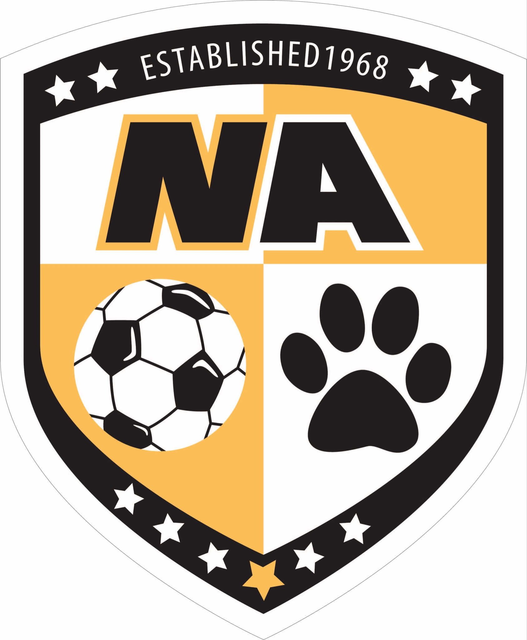

NA Boys Soccer Parent Orientation Meeting

June 2025

**Introductions:**

2025 Booster Board Members:

* President: Brian Sullenger (Contact info: 412-680-9768 or bmsullenger@gmail.com)
* Vice President: **Volunteer Needed**
* Treasurer: Anne Stalter
* Concession Stand Coordinator: Jeff Vaders
* Special Events Coordinator: Claudine Martin and Mara Paxton
* Information Technology: Cecile Ladouceur

Purpose of the Boosters:

* We are here to support the North Allegheny boys soccer program, athletes & coaches
* We are not involved with rostering, coaching or school administrative decisions
* We are a non-profit organization run by volunteers
* All Booster information can be found at <https://www.natigersoccer.com/>

**Communication:**

* Email us with questions: [natigersoccer@gmail.com](mailto:natigersoccer@gmail.com)
* Boosters website: <https://www.natigersoccer.com/>
* All off-season communications will be through PlayMetrics.
  + Sign up at [PlayMetrics.com](http://www.natigersoccer.com/teamsnap)
  + Coach Montero and the NABS Boosters will send periodic updates throughout the summer via PlayMetrics, so it is important you register
* All school-season communications will be through SportsYou.
  + Access is given to all families once NABS teams are announced.
* NA Athletics Boys Soccer website: <http://athletics.northallegheny.org/boys-soccer>

**Eligibility for Tryouts:**

Complete the following by **Friday, August 1, 2025**:

1. Completed ImPACT concussion test for rising 7th, 9th, 11th graders or those new to NA

2. Sports Physical (must be dated no earlier than 5/1/2025)

3. Family ID Registration (Opens on June 1st)

1. Create an account if you are new or log in if you are a returning athlete
2. Pay $75 participation fee

*You can call the athletic office (724-934-7238) to verify you have completed all steps correctly because your son will* ***not*** *be able to try out without this being done.*

Eligibility details: <http://athletics.northallegheny.org/school-physical-information.>

**Tryouts:**

* JV/Varsity tryouts are scheduled for August 11th, 12th & 13th
* Gold, Black & White Team tryouts will be held the Week of August 11th with the exact dates to be determined

**Note: All NABS prospects must participate in all three days of tryouts**

**Summer Training Opportunities:**

Coach Montero offers numerous opportunities for the boys to train over the summer through various training/conditioning sessions along with five summer camps. Attendance is not mandatory, nor will preferential treatment be given to boys who attend training sessions or camps when roster decisions are made, but the sessions/camps will improve players soccer skills and help the boys prepare for tryouts.

Montero Soccer Summer Camps

* Coach Montero has scheduled 5 summer camps (Weeks of June 9, July 14, July 21, July 28 & Aug 4).
* Attendance at camps is optional and requires registration fees
* Registration open NOW at <https://monterosoccer.com/camps/>
* Conducted by Head Coach Manuel Montero
* Email [m.montero415@gmail.com](mailto:m.montero415@gmail.com) with any questions
* Sessions will be included in the PlayMetrics calendar
* Rainout notifications will come from PlayMetrics.

Skills/Conditioning Clinics and Shooting Clinics

* Additional training sessions are scheduled throughout the summer
* Sessions will be included in the PlayMetrics calendar
* The full schedule can be found [here](https://docs.google.com/spreadsheets/d/1QCy2e6AgFe6dkKPRyFIXBGqVS3nglMFYoY8KOtVnpWk/edit?gid=1914204234#gid=1914204234).

**Volunteer Opportunities & Needs:**

The NABS Booster leadership team is a small group of volunteer officers with goals of supporting the North Allegheny Boys soccer teams during the upcoming season and helping to make the season memorable for the boys. The NABS Booster Board needs additional volunteers to achieve its goals and we would urge each family to consider getting involved and volunteering their time. **PLEASE CONTACT BRIAN SULLENGER IF YOU ARE INTERESTED OR WILLING TO VOLUNTEER!!!**

Key Volunteer positions the board is looking to fill include:

* **Website Design:** We are seeking a volunteer to help update our website. If you have experience, it would be greatly appreciated.
* **Team Parents:** A parent representative is needed for each of the five teams to assist with team management. Duties include managing the SportsYou account for that team and assisting with team pictures and uniform distribution and collection. A Team Parent is needed for: MS White, MS Gold, MS Black, Junior Varsity, and Varsity teams.
* **Team Photographers:** We are seeking a Team Photographer for each NABS team to provide action shots for our social media outlets, the NABS Yearbook, and Banquet presentations. If you’re a shutterbug and plan to attend most of your child’s matches, please consider volunteering for this role.
* **Special Events Committee:** We are seeking 3 - 5 volunteers to assist the Special Events Coordinators with duties related to planning NABS key events such as Elementary Night (Pack the Pitch), Middle School Recognition, Senior Night & End of Season Banquet.
* **Concession Stand Committee:**  We are seeking 3 – 4 parent volunteers to assist the Concession Stand Coordinator with various functions including opening/closing the stand for each game, ordering food/drinks, and managing the concession stand volunteers.
* **Ball-Boy Coordinator:** Ball-boys are provided by the home team for all JV and Varsity matches. We are seeking a volunteer toorganize and monitor the sign up of Ball Boys through Sign Up Genius to ensure ball boys are covered for games.